Delhi Public Secondary School, Robertsganj Holiday Homework (2020-21)

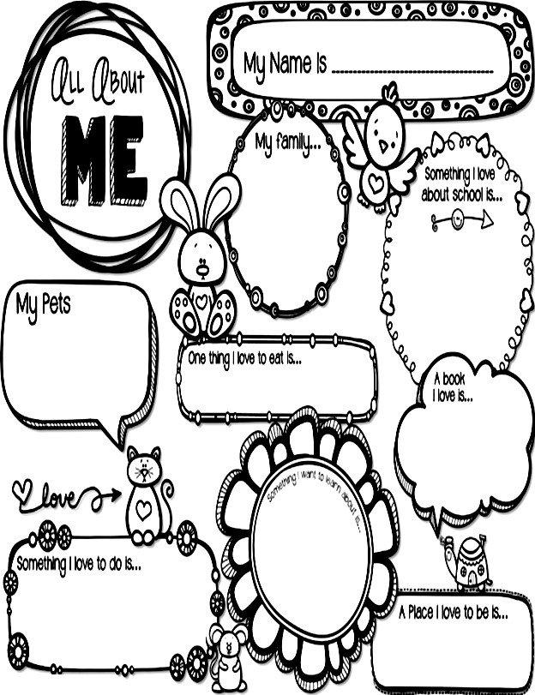

Class – I

**The summer holiday homework is also available on school’s website i.e.** [**www.dpssrobertsganj.in**](http://www.dpssrobertsganj.in)

Dear Parents,

“Despite the hot Sun, we can still have a lot of fun , so vacation is here for a sweet retreat”. Summer holidays are round the corner and some fruitful activities are designed at DPS to enhance children’s creativity and innovation for the progressive learning.

Help your child to do it :

**•Morning Blessings:**Help your child inculcate good habits like doing

“Surya Pranam”& encourage him/her to greet all elders in the morning.

**•Fun in Knowing :** Tell the child about your childhood, share incidents from the past and show him/her old family albums. This will strengthen the bond between you and your child.

**•Fun with Books:** Encourage your child to read books with moral.

**•Fun with family:** Make use of these holidays and spend quality time together as a family and make your child feel special.

**•Fun with Parents**: Cook dinner together. Show your child how to measure 1 cup, 1/2 , 1 teaspoon etc. Start naming the food groups when you serve them.

* **Let your child help in your household chores like cleanings windows, dusting and many more.**

•Have walk together and talk to your child about what he/she likes and dislikes etc.

•Help your child to memorize the home address and your phone numbers too.

•Help your child in learning how to open and close his/her water

bottle, lunch box, school bag .

HOLIDAYS…. FUN TIME…… PARTY TIME !!

* + **Do one page cursive writing of English & Hindi daily in separate notebook.**
  + **Learn & Write three new words from dictionary daily.**

# MAKE YOUR HOME A PLACE FOR READING

Here are some tips to help parents of young children to promote reading at home.

* Choose a reading time for your child, as in before a nap, bedtime, or after dinner.
* Select an age appropriate book for your child.
* Hold the book so that he or she can see the pictures, if possible, also let him or her turn the pages.
* Take time to look at and talk about the pictures. Don’t just read the story: talk about it.
* Let your child point out the letters, shapes, colours and animals.
* Read aloud to your child every day.

# Social Development

Imbibe following Social Skills in your child:

Greeting with a smile when someone comes to the house, preferably in English. Conversing freely but politely with visitors, relatives coming over to the house.

Answering the phone calls with a polite “Hello!” . Also asking “May I know who is calling”.

Sitting at the dining table with the family to eat the meals, using proper table manners. Do not watch television while having meals with the family.

Sharing toys, colours etc. with siblings. Talk to your child about:

1. The importance of keeping our surroundings clean.
2. The good habit of sharing and making friends.
3. Encourage your child to water plants.
4. Encourage your child to respect and help the elders at home.
5. Encourage your child to develop the habit of taking care of his/her belongings.

# Happy Father’s Day (17th June)

“A dad is someone who holds you when you cry, scolds you when you break the rules,

shines with pride when you succeed and has faith in you even when you fail….”

Take your father for a nature walk observe the beautiful plants around you with him.

Collect leaves of different sizes and shapes. Take your mother’s help and make a

beautiful greeting for your father with leaf printing and also make a smiley inside it.

# Surprise him by making sandwiches and lemonade in the breakfast for him with the help of your mother.

# Physical Development

* + Encourage your child to participate in dancing and singing activities.
  + Indulge your child in any one hobby like skating, basketball, dance, musical instruments, swimming tec.
  + Encourage your child to take care of ‘Personal Hygiene’ by inculcating the following habits:
  + Brushing teeth twice a day.
  + Combing hair regularly.
  + Bathing everyday.
  + Washing hands before and after meals.
  + Trimming the nails and keeping them clean.

# Inculcate following life skills in your child to help him/her become independent:

* + - Buttoning his/her shirt
    - Zipping and unzipping
    - Tying his/her shoes laces
    - Buckling and unbuckling
    - Turning pages of a book
    - Packing his/her school bags
    - Laying the table for dinner
    - Proper toilet training
    - Arranging shoes in the shoes rack

# Creative Development

* + **Create a beautiful craft using best out of waste material eg. Old cd, wool and news paper etc.**
  + **Create a beautiful scene with two living and two non living things on half size chart paper.**

SUBJECT - ENGLISH

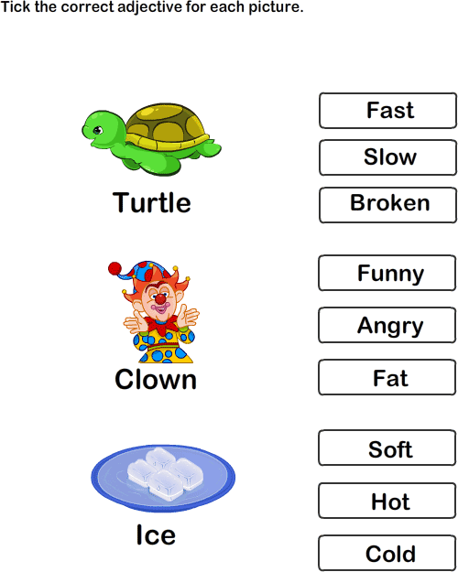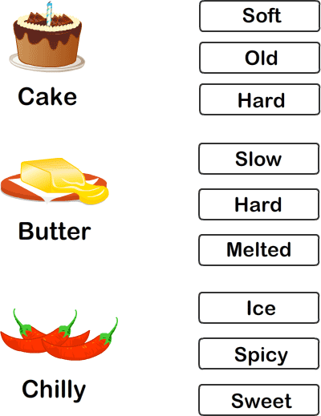

Read the comprehensions and answer the following questions.

A crow was hopping around a pond. Just then a flock of swans came flying, to the pond. They came with a loud flap, flap, flap! The crow said to the swans: Ugh! You do not know how to fly! Let us have a match to see who flthes better. I will show you what good flying is.

Answer the questions given below.

Q. What bird was hopping near the pond?

A.

Q. What birds came flapping to the pond?

A.

Q. What will the match, between the crow and swans, tell?

A.

Q. What will the crow show to the swans?

A.

Colour the circle in the centre with you favourite oder and colour the petals of flower accordingly.

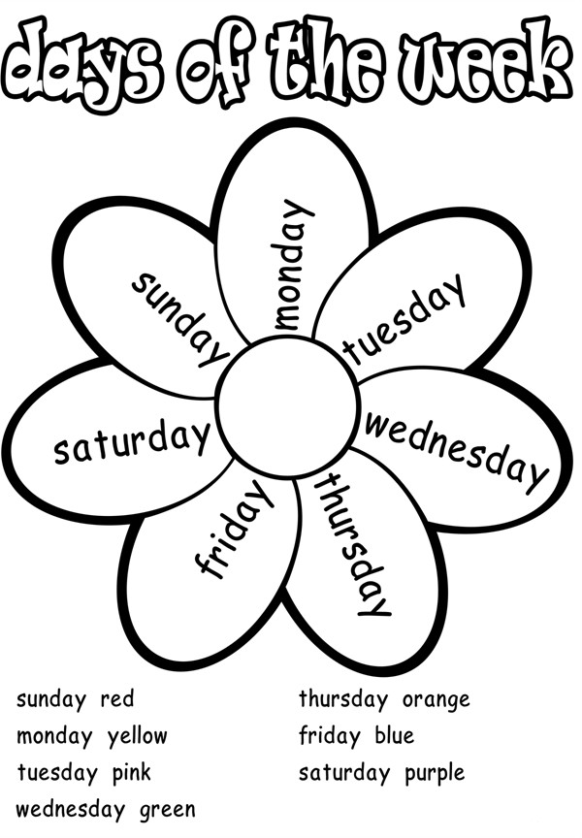

One and many

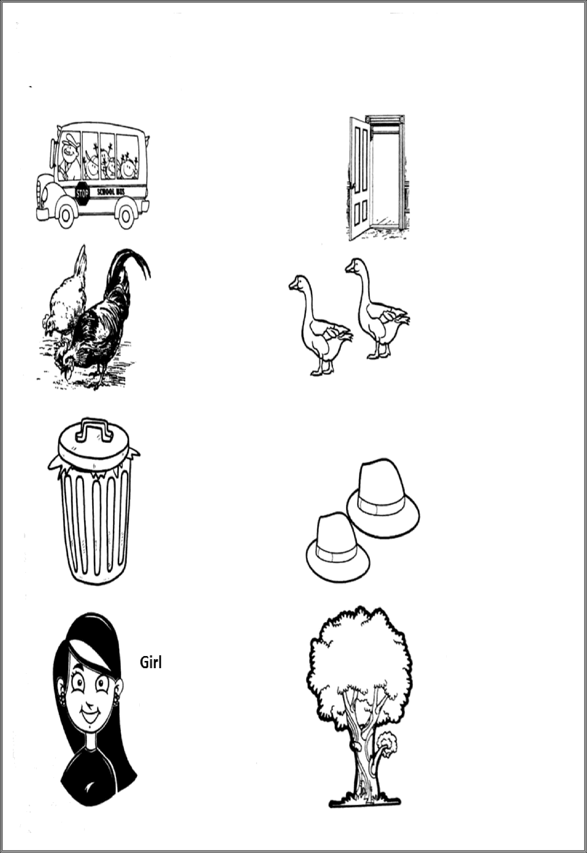

Circle the correct option for each other-

Bus Door

Buses

Doors

Hen Duck

Hens Ducks

Dustbin Hat

Dustbins Hats

Tree

Trees

# Complete the puzzle using the hint.

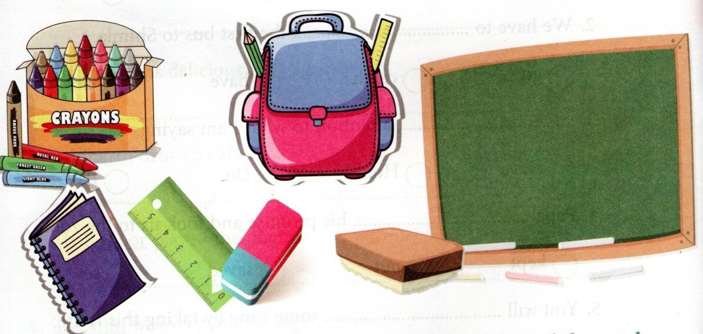

# 1.Teachers write on it.

1. **Teacher write with it.**
2. **They come in different colours.**
3. **It is made of wood.**
4. **It removes pencil marks on paper. 6.Work you do at home.**

**7. Clothes you wear to school. 8.You write in it.**

1. **We draw lines with it.**
2. **We carry books in it.**

# Choose the correct describing words from the bracket and fill in the blanks.

1. **Riya got some pastries for us.(bitter/tasty)**
2. **He is a man. (dry/rich)**
3. **India is a country. (large/full)**
4. **She is a very girl.(happy/wet)**
5. **These are grapes.(weak/fresh)**

SUBJECT - MATHEMATICS

* 1. **Que. 1 Write the number and number names of the following:**

1 tens and 5 ones:

3 tens and 6 ones:

__________________

__________________



2 tens and 7 ones: __________________

4 tens : ___________________

**Que. 2 Fill in the missing numbers:**

|  |  |  |  |  |
| --- | --- | --- | --- | --- |
| **111** |  |  | **114** |  |
|  | **117** |  |  | **120** |
| **121** |  | **123** |  |  |
|  | **127** |  | **129** |  |
|  |  |  | **134** |  |

* 1. **Que. 3 Arrange the numbers in ascending order:**

25, 19, 33, 17, 8: _______________________________________________________________________

28, 15, 22, 10, 9:_______________________________________________________________________

8, 17, 99, 13, 11: ______________________________________________________________________

|  |  |  |
| --- | --- | --- |
| **Que.5 What comes after:**  **26 ____** | **41____** | **47____** |
| **73____** | **76____** | **96____** |
| **71____** | **82____** | **93____** |
| **78____** | **50____** | **80____** |
| **Que.6 What comes before:**  **___55** | **___58** | **___90** |
| **___50** | **___75** | **___84** |
| **___88** | **___40** | **___63** |
| **___59** | **___19** | **___78** |



* 1. **Que. 7 Arrange the numbers in the descending order:**

21, 78, 63, 66, 11: ______________________________________________________________________

25, 81, 16, 6, 50: ____________________________________________________________________

33, 17, 76, 86, 10: _____________________________________________________________________

* 1. **Que 8. Make a list of round object, long object & draw pictures.**
  2. **Que 9. Write & learn tables from 2 to 10.**
  3. **Que 8. Write numbers in words from 1 to 50.**
  4. **Que. 9 Make a calendar of your birthday month on A4 size sheet & highlight your birth date. Make a cutout of the number matching your age for example 6 & decorate the same with the picture of your favourite things for example cartoon, chocolate etc.**

Que. 10 Present the following information beautifully on an art sheet, paste your recent photograph and complete the information about yourself.

1). Number of letters in my name

2). My age

3). My class

4). My weight

5). Number of members in my family

6). Number of teeth I have

1. My shoe size
2. My father’s contact no.
3. 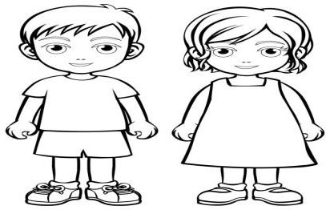My mother’s contact no.

# Hey friends,Lets do it-

# 1. Do page no. 1 t0 11 in book.

# 2. Given sheets will be done in your copy.

## SUBJECT - EVS

Q1. Have a close look to your surrounding while you are in the park. Observe how beautiful the flowers & plants are, how people are having fun & all the activities that you do to make your day memorable one. One A3 size sheet using materials such as dried leaves, match sticks, pencils shaving, cotton etc. Create a scene of the park you visited.

**Q2.** **How to plant seed**

Using the words in the box,fill in the blanks below-

bucket ,soil , water , garden , hand,water , seed ,sun ,plant

Place some into a

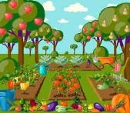

Make a with your

Drop some into the

Cover the with



Pour into the

Give your lot of

Wait for your new to grow!

**ANIMALS**

### Write the animals name for each letter-

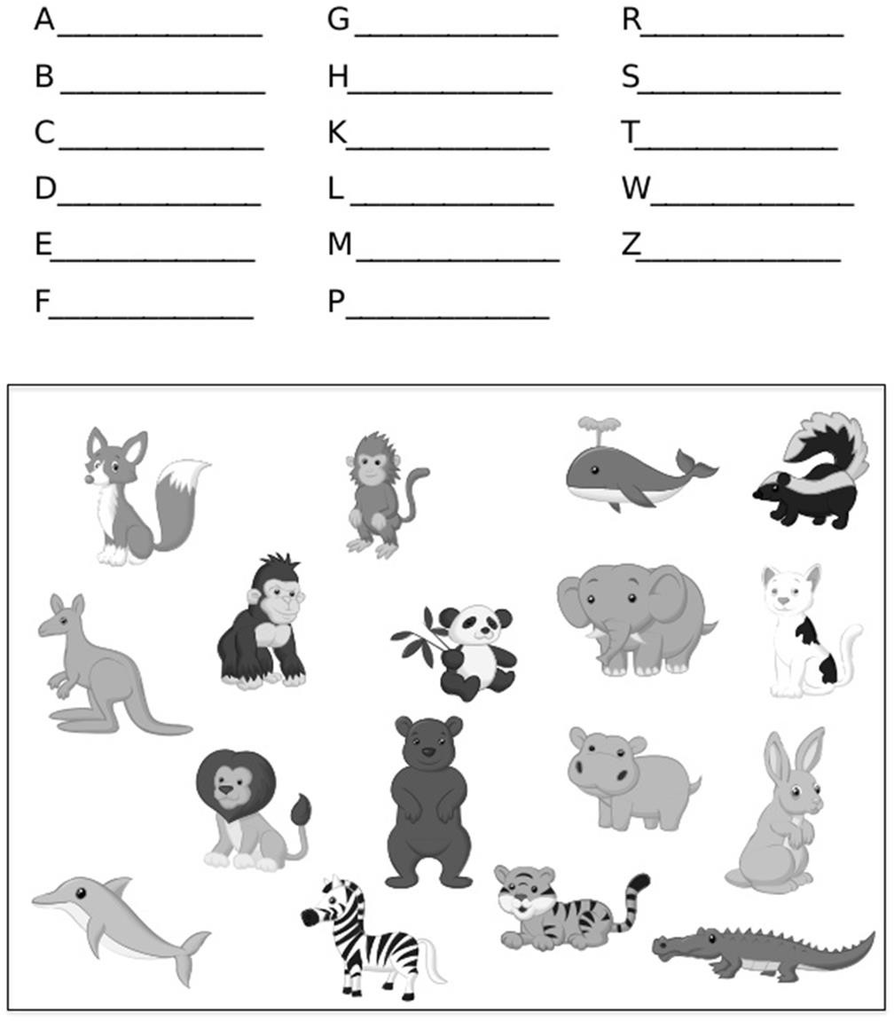

Plant Needs

Help Jack decide what a plant needs. Draw the items which a plant needs to grow around the happy plant.

Draw the items a plant doesn’t need beside the unhappy plant

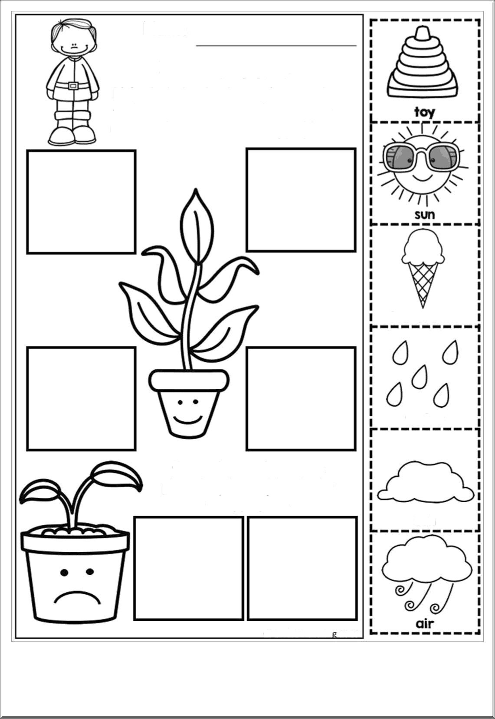

**My Family Tree**

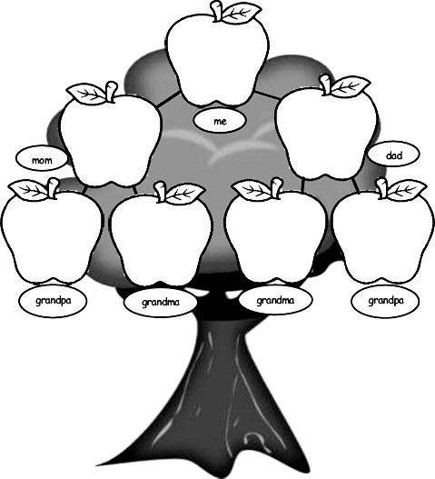

Paste the picture of your family members in the given Family Tree

Theme- INDIA RISING

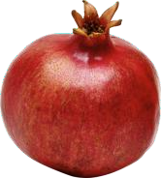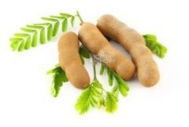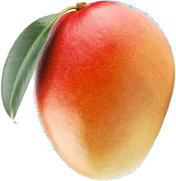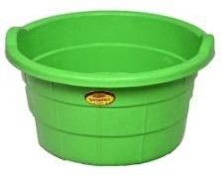

Research Work

* + - **Find out the number of states in India and try to learn their names.**
    - **Find out the number of languages spoken in India.**
    - **List out the names of cities that you have visited in India.**

## हिन्दी

**1. चित्रा को पहचांकर उनके नाम लिखिएi**

### ------------------------------------------------------------------------------------------

--

------------------------------------------------------------------------------------------

------------------------------------------------------------------------------------------

------------------------------------------------------------------------------------------

------------------------------------------------------------------------------------------

|  |  |  |
| --- | --- | --- |
| **¼2½** | **ik¡p पक्षियों केuke fyf[k,&** |  |
|  | ¼d½&&&&&&&&&&&&&&&&& | ¼[k½&&&&&&&&&&&&& |
|  | ¼x½&&&&&&&&&&&&&&&&& | ¼?k½&&&&&&&&&&&&& |
|  | ¼³½&&&&&&&&&&&&&&&&& |  |
| **¼3½** | **ik¡p अंगों के uke fyf[k,&** |  |
|  | ¼d½&&&&&&&&&&&&&&&&& | ¼[k½&&&&&&&&&&&&&&&&& |
|  | ¼x½&&&&&&&&&&&&&&&&& | ¼?k½&&&&&&&&&&&&&&&&& |
|  | ¼³½&&&&&&&&&&&&&&&&& |  |



## ¼d½ दिये गए वर्णों के दो – दो शब्द लिखिए

ख ट प

खरगोश

**खरबूजा**

**ध न म**

**j y t**

**¼x½**